Territory Sales Plan

Purpose 2
Assessment 2
Company Profile 2
Current customers 2
In territory 2
In other territories 2
SWOT Analysis 2
Absolute differenciator 3
Strategy 3
Goals & Milestones 3
Target companies 4
Target individuals 4
Messaging 4
Lessons Learnt 5
Reviews and adjustments 5
Change history 5

Purpose
The objective of this document is to capitalize on the information resulting from the approach to the territory. Who are the company's customers, how do they respond to requests and what are the assets that make it possible to enter a new account?
This document is evolving.

In the process of entering a new territory, it is essential to rely on concrete elements based on experience. We need to figure out who the company's potential customers are and how to get their attention.

Assessment

Company Profile
Our Company is ….

Current customers

In territory
List current clients in territory ….

In other territories
List current clients in other territories ….

SWOT Analysis
Strengths | Weaknesses
Opportunities | Threats

COMPETITORS
Name | Notable attributes | How did we find them
Competitor 1

Absolute differenciator
Explain here what differentiates your Company….

Strategy

Goals & Milestones
Grow the company client’s base and grow revenue in New territory.
Explain the Company overall objectives Here …

MILESTONE 1
DUE | 31/03/2021
GOAL | GOAL [add title]  Add details here … - needs to be SMART Goals
APPROACH | Detail approach here …
PERIODICAL CHECKS | Date 1 – detail the purpose of the check and results here…
SUCCESS? |  | YES/NO

MILESTONE 2
DUE | 31/03/2021
GOAL | GOAL 1 [add title]  Add details here … - needs to be SMART Goals
APPROACH | Detail approach here …
PERIODICAL CHECKS | Date 1 – detail the purpose of the check and results here…
SUCCESS? |  | YES/NO

MILESTONE 3
DUE | 31/03/2021
GOAL | GOAL 1 [add title]  Add details here … - needs to be SMART Goals
APPROACH | Detail approach here …
PERIODICAL CHECKS | Date 1 – detail the purpose of the check and results here…
SUCCESS? |  | YES/NO

Target companies
Industry
Geography
Size
Notable Attribute
Notable Disqualifiers

Target individuals
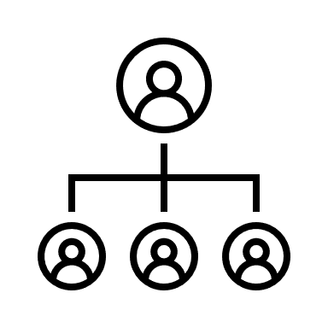 | Responsibilities
 | Job Titles
 | Notable Attribute
 | Notable Disqualifiers

Messaging
detail initial messaging here ….

What terms seem to make targets click?
Add notes here as you learn about the territory ….

Lessons Learnt
1 | Lesson learnt 1… | Explanation…

Reviews and adjustments

Change history

Date | Change & Reason
01/02/2021 | #Initial release…

